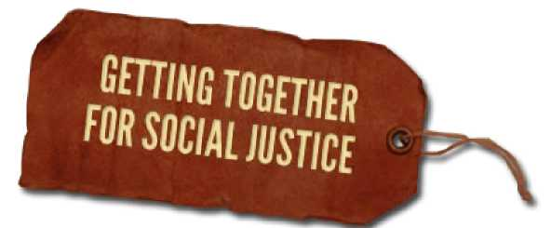
Breaking White Silence and Stepping up your work for Racial Justice

Compiled by Paul Kivel
You have Resources to leverage for racial justice!

- Money—direct donations, hosting house parties

- Time—support work, administration, research, filing

- Skills—fundraising, web-based, outreach, childcare, writing, music, art, carpentry

- Connections—to journalists, politicians, decision-makers, funders

- Space—providing space in your house, office bldg., religious or community organization for meetings, living room gatherings, workshops, or art builds

- Organizational leverage—working for organizational change where you work, where you go to school, where your children go to school, at your religious or community center.

- Information to share—about racism and other issues of social justice, about how systems work, about organizing, fundraising, etc.

- Access to white people—family members, friends, neighbors, co-workers, classmates

- Credibility with white people

- Access to young people as parents, teachers, youth workers, aunts, uncles, grandparents

- Your body on the line—showing up for rallies, vigils, protests, city council meetings, school board meetings, etc

- Witnessing, recording, interrupting, and reporting—incidents of police harassment and brutality, incidents of discrimination and marginalization, overheard personal comments, organizational practices and policies, or on on-line sites

- Amplifying Black Lives Matter messages—through personal networks, facebook, twitter, letters to the editor, public signs, t-shirts, yard signs

Please educate yourself in the issues, work with others, and be accountable to the Movement for Black Lives, Indigenous nations, and other people of color led communities in your use of your resources

