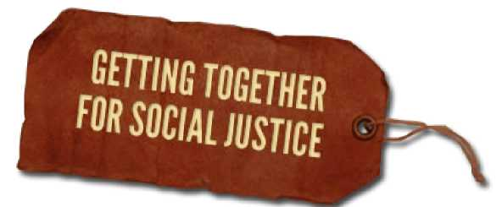

The Enemy Within
From: Uprooting Racism, 4th Edition, Part II The Dynamics of Racism
By Paul Kivel
One of the purposes of racism and religious-based pppression is to keep people of color, Muslims, Jews and others at the center of attention while keeping white people in general, and white male Christians in particular, at the center of power and at the top of the
economic pyramid. The majority of people in the US have been abused, economically exploited and discriminated against. We experience tremendous physical, economic and emotional loss from social inequity and personal abuse. Like the proverbial thief who points off in the distance to get you to look away and then deftly picks your pocket, systems of oppression divert our attention from
those who have the real power to rob and hurt us. In our pain and anger we often turn against traditional scapegoats and blame people who are less powerful than we are.

People of color, immigrants and people who are not Christian have long been portrayed as economic threats to white Americans. We have heard and perhaps used phrases like “They take away our jobs.” “They are a drain on our economic system, eating up benefits.”
“They drive wages down.” Or, about Jewish people in particular, “They control everything.” “They rob us blind.”

In fact, these targeted groups of people are not the ones who make the economic decisions that affect our communities. Corporate leaders lower wages, inflate prices and sell us shoddy and dangerous products with impunity. In the US, there has been an enormous redistribution of income toward the rich in the last 40
years, while the standards of living for the rest of us have decreased.1 Simultaneously, our national infrastructure has deteriorated, living wage jobs and affordable housing are beyond the reach of millions,
and our schools are falling apart. We hurt ourselves and make it impossible to solve our social problems when we don’t understand the economic basis of racism. Meanwhile, the rich keep getting richer. In order to address racism effectively, we need to become better at analyzing where real power lies. Which groups are making important political and economic decisions and which are being blamed.

